Question1:

Screenshot of successful practice of launching and managing a VM instance.

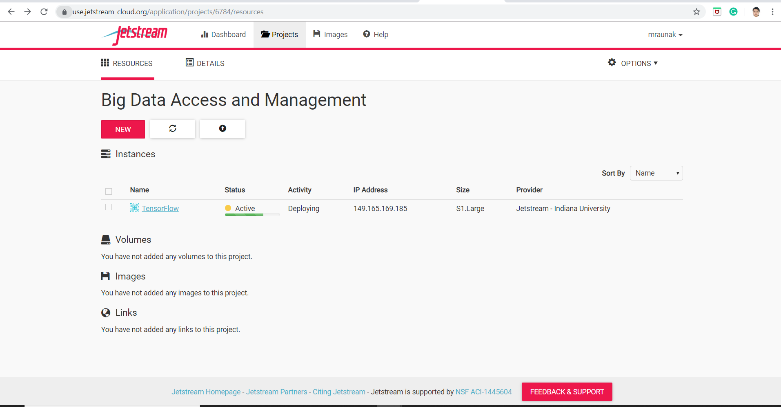

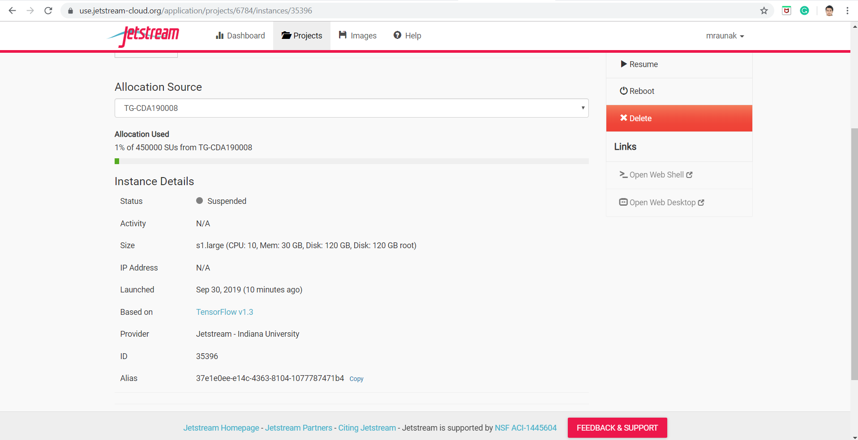

After successful launch, Currently, I have changed the status to ‘Suspended’

The Jetstream user guide helped to get good understanding about the Jetstream which is user friendly cloud environment which was designed with a motive of interactive data computing and analytics. User can use this anywhere and anytime.

Jetstream helps to create user customized virtual machines on their private computing system within jet stream.

To create an instance, I followed the following steps:

1.Clicked on the Launch New Instance and choose one of the featured images.

I choose tensor flow and Jupyter notebook

I gave the project name and details.

2. Dialogue box appeared asking for the basic options:

Selected provider as ‘Jetstream Indiana University’ and selected the instance size according to the need.

This screen gave me information about the resource’s allocation.

3. Initially the status of my instance was ‘build’ and then after 3-4 mins, it changed to active and my ip address appeared

4. I performed suspend operation as I want to come again and explore the tool.

This way, I successfully created an Instance. I didn’t get any trouble, but a little delayed response from the site.